**Empowering Women to Empower Communities through Afya Micro-Finance**

1. **Background**

According to Tanzania Private Health Sector Assessment report, 60% of the population use ADDOs as their first entry points to access health services. Despite the huge demand in this sector, the ADDO shops owners have always had challenges in accessing financing in-order to stock their shops with the right quality and quantity of essential medicines recommended for their shops. This has led to frequent stock-outs of essential medicines, low quality medicines and increased prices on medicines for the final beneficiaries. The aim of Afya Micro-Finance project is to empower communities especially women who in most cases are the ADDO shops owners to access high quality medicines through reputable suppliers, appropriate quantity and at an affordable price. This would in turn reduce the cost to the final beneficiaries; ensure they access good quality and all essential medicines as required.

The aim of Afya Micro-Finance project is to empower communities especially women who in most cases are the ADDO shops owners to access high quality medicines through reputable suppliers, appropriate quantity and at an affordable price.

The case of Ms. Agnes Nyasebo is a success story of how women have been empowered through loans provided by AMIF to start up a new ADDO shop in one of the Peri-urban areas of Dar es Salaam city. Agnes Nyasebo is a widow and has been working as a Nurse Mid-Wife in one of the facilities nearby her home in the Peri-urban area. Agnes knew the huge need of the area for an ADDO shop to provide essential medicines since there was none nearby. She started selling essential medicines from her house and in small quantities due to lack of enough capital. Agnes later approached various banks but none of the banks was willing to give her a loan due to lack of collateral.

1. **Intervention**

AMIF focuses on providing loans to individuals especially women in Peri-urban and rural areas who intend to start up new ADDO businesses or those who wish to scale up their exiting ADDOs. The loans from AMIF are aimed at increasing the existing capital, renovation of premises or as new capital for starters. Agnes learnt about AMIF through a sensitization meeting organized by AMIF and approached AMIF staff in September 2015 seeking financial support to renovate part of her house to an ADDO shop, and to add working capital to her business for more stocking of essential medicines.

Agnes was awarded an initial loan of One million Tanzania Shillings (330 GBP) which would help her register her business legally, renovate the room to meet the ADDO shops standards and add more stock of medicines. Agnes was also linked to a reputable supplier who AMIF had negotiated the prices of commodities lower that the normal market prices. Agnes managed to repay the loan in six months with no single default or arrears. After six months she took a second loan of Three million to scale up the business, which she is currently repaying.

1. **Outcome**

Agnes has been able to register her business with all the regulatory bodies i.e. BRELA, Pharmacy council and local business council. Currently Agnes is able to stock all essential medicines in the drug list for an ADDO thanks to the loans that she has received through AMIF. Before the intervention of AMIF, Agnes was making average sales of TZS 15,000 with 3 clients per day. However, after the first loan, her average daily sales increased to TZS 80,000 with 15 clients per day. Furthermore, after the second loan Agnes business performance increased further to an average of TZS 150,000 as daily sales with over 40 clients being served in her shop daily. Agnes has also now employed a drug dispenser. She has also been able to reduce the prices of some commodities due to the negotiated prices she has from suppliers and number of sales she makes in a day.

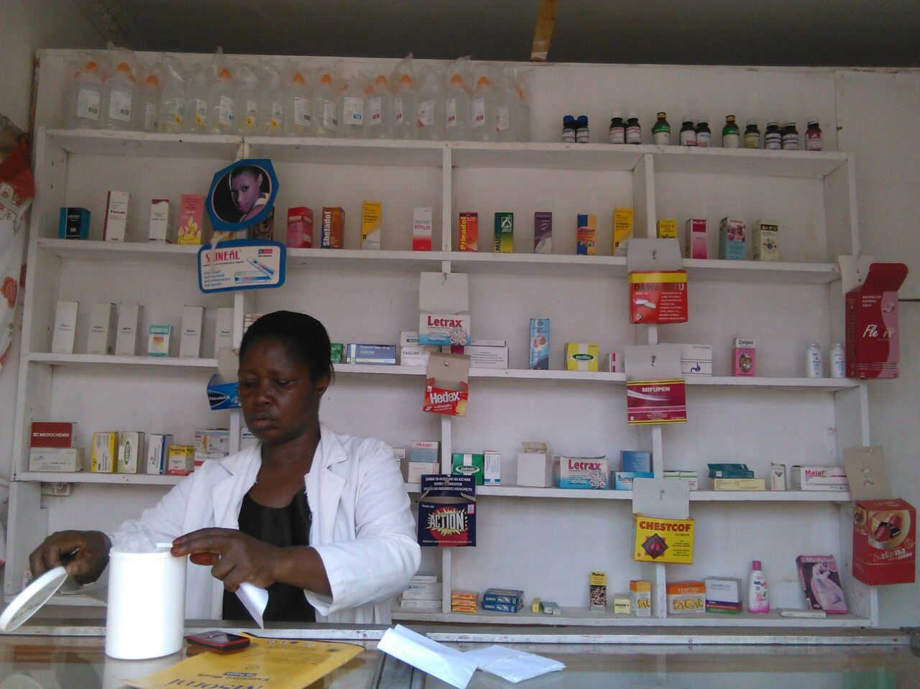**“Most of the clients I serve in my shop are women and children with the fast moving drugs being anti-diarrhoea, anti- malaria’s, Antibiotics and family planning pills” says Agnes.**

Agnes Nyasambo believes that she will do more and succeed in life through support from AMIF. She is currently building a laboratory in her efforts towards expanding her business and widening revenue sources. All these have been achieved in a spurn of one year! And what is in her future plans: to own and run Maternity Home and dispensary. With AMIF she is confident she will achieve her goals!

1. **Conclusion**

Through this project there has been transformation of lives at the target group level and the final beneficiaries. Target groups have been able to improve their businesses through increased income, expand the type of services offered and serve more clients. In addition, health care services have been brought closer to communities, and the services have been made accessible and affordable to many. It’s expected that more people like Agnes will continue to benefit from the project and the project will contribute to its goal of reducing Maternal and Child Mortality since most of the clients accessing services at the ADDO shops are women and children.