**Dageno Girls Center: Impact on a Student**

When Dageno secondary school for girls opened its doors four years ago, then fourteen-year-old student Maggie was unsure what to expect. It was her first time away from home. She was the first of her siblings to go to school. She did not speak Swahili or English.

Maggie came from the small village of Endashangwet near Ngorogoro crater in rural Tanzania. One of six daughters, she has never seen her father’s face. Her mother did what was needed to survive, eventually raising goats to feed her children. Maggie’s two older sisters were home waiting to marry. Most other village girls of Maggie’s age would soon be mothers or marry, sometimes against their wills. They would have no education. They would have very little social or economic power. Many would return to their parents’ houses or find transactional relationships with men to survive.

Maggie has other options. If she decides to marry, she says, it will be after she has reached her goals. Her goals are specific: go to university, become a journalist or teacher and start a business.

Maggie expects to be the leader of her life. "In the future I will depend on myself because I am getting more power. When you grow you know many things and know ways to solve different problems,” she says.

She has grown significantly during her four years in the Dageno environment. The Dageno curriculum and pedagogy is vastly different from other schools in Tanzania. The curriculum consists of five parts: Academics, Sigi, Akiba, Care and Co-laboratory.

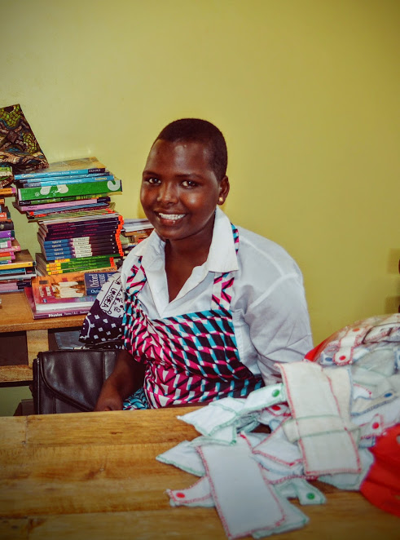Academics cover the topics prescribed in the government curriculum, but the pedagogy differs from the rote teaching and learning style of government schools. Rather than copy notes from the blackboard and listen to lectures, students are challenged to learn through practical application and problem solving.

"Leadership means that I do not have to wait for people to tell me what to do,” says Maggie. “If I notice something, I can do something. If I see a problem, I can fix it.”

For example, Maggie learned about pathogens and the spread of illness while working with her fellow students to design the toilet and shower block for the campus. Through practical challenges, Maggie and her classmates have literally shaped their campus. Students have designed their own uniforms, tables, beds, couches and benches and desks.

**Dageno Collaboratory Overview**

* **Academics:** Dageno academics have flexible entry points to accommodate students whose educations have been interrupted. There are flexible learning spaces for varied and dynamic interactions. Academics focus particularly on science, math, and engineering. Lessons plans cover all government required subjects for Forms 1-4. Academics are taught largely through practical design challenges and real-world application. Core foundations for academics include communication (English and Swahili), study and test-taking, math basics, and leadership and life skills.
* **Sigi:** Dageno develops the whole person, preparing girls with leadership and life skills required for contemporary economies. The term *Sigi* comes from the local Iraqw tradition of taking adolescent girls—called Dageno—away for three years to be taught life skills by grandmothers. Sigi addresses five elements of the person: body, mind, hand, heart and soul. Students are encouraged to exercise 8 C’s: curiosity, creativity, critical thinking, collaboration, confidence, courage and communication so they can be change-makers.
* **Akiba:** Students gain practical experience learning to build and manage small businesses. Akiba means *savings* or *something valuable* in the local Iraqw language. Dageno uses the Teach a Man to Fish curriculum. Students work in teams of ten with elected captains and co-captains to test and develop business ideas with a focus on user-centered design. Seed funds for enterprises are drawn from the students’ income from other ventures.
* **Care:** Student’s emotional and relational well-being is supported through a combination of student-managed norms, restorative justice and mediation approaches, personal counseling and art therapy. Teams of students manage different facets of the school norms. Every week a sisterhood meeting allows students to raise and address issues.
* **Collaboratory:** Every Saturday students have “tinker time” in which they can make or do any activity of interest. The school has plans for design labs and creator spaces for Dageno and the community.

The practical challenges integrate academic learning objectives with design-thinking approaches and the development of life-skills. Each practical challenge draws on the 8-point life-skills framework that the school calls Sigi. Students practice communication, presentation, cost benefit analysis and decision-making as they make real choices for their campus.

Dageno takes the training even further. Students learn to build and run businesses. They call this training Akiba, which means “savings” or “something valuable”.

“Problems are opportunities because they can be made into businesses,” says Maggie. “You can find a solution to the problem, and that can become a business.” The girls designed and will sell a locally made, reusable sanitary napkin. They are launching a fresh fish aquaponics business to meet demand from safari lodges in the area.

"The [Dageno] environment is impacting the girls,” says guidance counselor and civics teacher Eunice. "This place supports them to be leaders and be productive in their society. For other schools there is nothing like leadership. Here they are told that everyone is a leader and can be a leader. So they can see themselves as a leader. We encourage them that even if they fail, they can do it again."

Maggie is one of twelve girls who undertook and passed their Form Four tests this last year. By contrast, no student from the neighboring government school passed the exam. The academic success of the students has garnered the attention of area parents. The student body doubled in the most recent academic year and includes Maggie’s younger sister, Philomena, in Form One.

Maggie is now embarking now on her Open University studies that prepare her to qualify for a Tanzanian university program. There remain challenges ahead. But Maggie is curious, she loves learning and she has skills. She knows she can find a way. She later wants to return to her village to teach the young mothers how to make soap and earn a profit for their families. “People have helped me. When you are helped, you go to help others,” she says.

"I love Dageno so much because we are learning many things. And [founder] Madame Andie helps us so much. She helps us find other solutions to problems. She has helped so many girls of Tanzania. We don’t have anything to give her. We can just say: God bless her. We can just tell her thank you and for her to continue and reach her goals. And we can say thank you for others who are supporting her to do her program."