**Girl Power: Innovation in Tanzanian Education**

In the small town of Karatu near Ngorogoro Crater in northwestern Tanzania, a hundred girls ages 14-21 are undergoing training for life. They live together. They learn together. They create together.

These *dageno*—girls of adolescent age who leave home for years to train in life skills—have inspired an innovative educational center by the same name: Dageno Girls Center.

Dageno combines imported concepts like student-centered learning, design-thinking, female empowerment and leadership development with local Iraqw tribe traditions and standard Tanzanian academic requirements.

Founder Andie Trotter describes Dageno as a “’design thinking and doing,’ experiential, entrepreneurial education center for Tanzanian girls at high risk of early marriage, teenage motherhood, HIV infection, and exploitative pathways in life.”

The educational center[1] is progressive by most global standards. In Tanzania, it is vastly different from government and most private schools teaching the 24% of Tanzanian girls who attend secondary school.[2] In Karatu, Dageno is creating the possibility for new life trajectories in a context in which girls and women have very little education, social or economic power and must regularly enter into transactional sexual relationships with men to survive.

Dageno is creating the possibility for new life trajectories in a context in which girls and women have very little education, social or economic power and must regularly enter into transactional sexual relationships with men to survive.

Six things differentiate Dageno Girls Center:

1. **Flexible Entry**

Because many children had their primary or secondary school education interrupted, Dageno has developed a three-month Foundations Bootcamp. This includes intensive English, phonics, writing and math. There is also a modular Power Hour every day focused on the cluster of skills individual students require. Students must pass a test to graduate to the next level in a given topic. Students entering with higher levels of education can test out of modular topics and into the appropriate form level one through four.

1. **Leadership and Life Skills**

Dageno draws from the Iraqw tradition of Sigi, a three-year period in which adolescent girls leave home to be trained by grandmothers in essential life skills. The life skills emphasized at Dageno are suited to the modern economy. Students are encouraged to exercise 8 C’s: curiosity, creativity, critical thinking, collaboration, confidence, courage and communication so they can be change-makers. Girls are challenged to be leaders and given opportunity to develop leadership abilities.

1. **Learning by Doing**

The 8 C’s provide a framework for girls actively to engage in their own education. Academic subjects are taught in part through practical design challenges. For example, students learned biology and geometry while designing their own toilet and shower block on campus. Students are encouraged not only to learn information, but also to identify what information they need to obtain to accomplish a challenge. They analyze varying options and select the best one. This approach takes students into higher levels of Bloom’s taxonomy of learning.

1. **Entrepreneurship**

Dageno further emphasizes design challenges, curiosity, collaboration, leadership and problem-solving while students practice developing small businesses. Students use design thinking to meet problems and market opportunities in their communities. They use customer interviews and other design tools to create solutions. The entrepreneurship curriculum draws from Teach a Man to Fish.

1. **Design-Thinking**

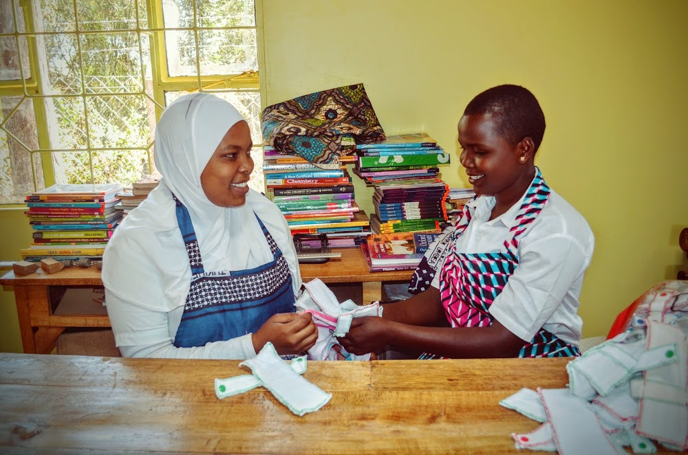Students are taught to think of the usage, needs and preferences of users in designing solutions. Design-thinking is integrated into practical design challenges and has resulted in a campus literally shaped by the students, from dorm beds to classroom desks to uniforms. Focus on the customer and end user also teaches students to create businesses with a product-market fit.

1. **Protection**

Dageno is a full-time boarding school in part to reduce the likelihood that girls will have to withdraw or interrupt their studies due to pregnancy. Mobile phones are prohibited on campus. Dageno has a contract with parents whereby parents agree to protect their girls during vacations and repay scholarships if they remove their girls for marriage or pregnancy. Dageno has the option to sue if parents breech the contract.

**The Dageno approach to teaching girls is yielding results. Of the twelve Dageno students who took the standardized Form IV exam of 2015, *all* passed. By contrast, *none* of the students from the neighboring government school passed. Nationally, only 67% of students passed.[3] In Tanzania, education only advances when children pass the exam.**

While pleased with the results, Dageno Girls Center is focused on helping girls advance in life, not only in school.

The girls know this. When asked what is different at Dageno from other schools, a confident, self-possessed Form III student named Gertrude replied, “We will pass Form IV and pass on to Form V. If you are a Dageno student, you can start your own business because you have knowledge on how to do things. So you can start to make money yourself. From the skills that I get at Dageno, especially from leadership and entrepreneurship, I can make something different that other students cannot.”

1. Dageno Girls Center is considered a non-profit tuition center rather than a school within Tanzanian law.
2. [Tanzania Core USAID Education Profile](http://www.epdc.org/sites/default/files/documents/Tanzania_coreusaid.pdf), Education Policy and Data Center, sources 2004 and 2010 household surveys.
3. [*Slight Drop in Form IV Exam Performance*](http://www.dailynews.co.tz/index.php/home-news/47132-slight-drop-in-form-4-exam-performance), The Daily News, 19 February, 2016.