**Simple yet adaptive technology means access to affordable, safe and clean drinking water for all**

**By Joanna Martin, Indigo MTPC**

Arusha, Tanzania, 11 October 2016 -If you enter Gongali Model Limited headquarters in an industrial estate in Arusha Town you will see a husband and wife team, Dr. Askwar Hilonga and Ruth Elineema focusing hard on striving to make their water filter, better, faster, more slim line in shape. This filter doesn't only belong to them, it belongs to everybody and you distinctly get that impression when you witness their daily morning sales meeting, punctuated by a staff member on piano playing uplifting tunes accompanied by staff singing. "It's all part of boosting morale," said Ruth Elineema, CEO of Gongali Model Limited, who despite being small in stature carries serious weight and has big ideas, she wants to expand and reach out to the East African Community if not the entire continent, when it comes to espousing the virtues of the innovation. In short, it is a simple water filter (NanoFilter) using slow sand filtration technology and has a secret material, think Coca-Cola with patent pending, and adapts according to local water conditions. The effect is profound; it is dramatically improving the quality of 7,768 people's lives across Northern Tanzania and giving them access to safe and clean drinking water at an affordable price.

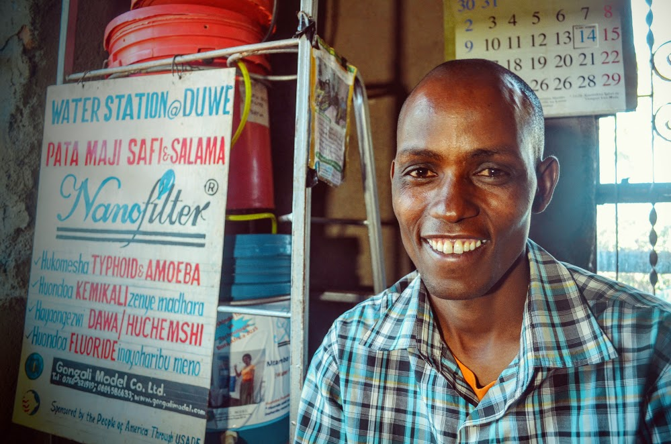

The filter has proved to absorb harmful substances including copper and lead and breakdown bacteria and microorganisms, preventing water-borne diseases such as typhoid and cholera. "We adapt the filter according to the specific location. Special materials target specific chemicals or contaminants found and that is why we send an engineer out to each site to make assessments," said Dr. Askwar Hilonga, inventor of the NanoFilter, who developed the product at the Nelson Mandela Institution for Science and Technology in Tanzania. "But the next challenging step was taking this product from the laboratory to the market, and with the help of the Human Development Innovation Fund (HDIF) this has been made possible," Dr. Hilonga added.

Over a period of three years, Gongali Model, in partnership with the Nelson Mandela Institution of Science and Technology has been able to develop the product further and recruit a dedicated sales and marketing team to empower people to sell the water within communities at a reasonable price.

"I use the filter to provide safe water to my community and my family," said Entrepreneur Elifuraha Daniel, who has been hiring the NanoFilter for two years. Mr. Daniel collects water directly from the nearby river in his village, Gongali in Karatu, Arusha Region and is able to sell 120 litres of clean and safe filtered water each week to his neighbours.

“The NanoFilter serves its customers directly. They are listening to people's needs and speaking in a language which touches people's lives directly,” said **David B. McGinty, Team Leader, HDIF**