**kiswahili**

**KUMBUKUMBU YA SIKU YA WAFAAT YA MUASISI WA BILAL MUSLIM MISSION OF TANZANIA**

Hawzatul Bilal - Temeke ilifanya kisomo cha Khatmul Qur’an baada ya sala ya Dhuhurain, ambapo Shk Iddi Ibrahim alielezea kwa mukhtasar maisha ya Marhum Sayyid Saeed Akhtar Rizvi ambaye ndie muasisi wa Bilal Muslim Mission of Tanzania. Siku kama ya leo tarehe 8 Jamadiul Akhaar mwaka wa 1423 ilikuwa ni siku ya huzuni kubwa kwa Mashia wote Duniani kwa kifo cha Aalim mkubwa kama yeye kutoweka juu ya mgongo wa ardhi hii yenye mapambano makali katika kueneza ujumbe sahihi wa Mtume (S.a.w.w.) na Ahlul bayt wake.

Marhum Sayyid Saeed Akhtar Rizvi katika harakati zake alizozifanya kuutangaza ujumbe sahihi wa babu yake Bwana Mtume (s.a.w.w.) hakuna hata Mshia mmoja aliye tashaiyah hakupita bila ya athari itokayo kwake ikiwa ni kwa moja kwa moja au kwa njia nyengine.

Tunamuombea Allah (s.w.t.) ambarik kila la kheri, na atujaaliye tuendelee kuwa chini ya kivuli cha Maulamaa wetu watukufu.

Sayyid siku zote atakaa katika vifua vyetu, fikra na harakati zetu, ni kigezo chema kwetu katika Bara la Afrika ya Mashariki.

**english**

KHITMA OF SAYYID SAEED AKHTAR RIZVI

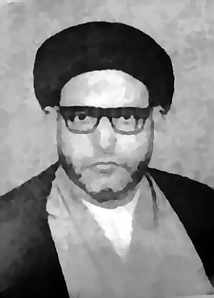

MEMORIES OF THE DAY OF WAFAAT FOUNDER OF BILAL MUSLIM MISSION OF TANZANIA

Hawzatul Bilal - Temeke made Khatmul recitation of the Quran after prayers of Dhuhurain, where Shk Ibrahim Iddi explained abridgement life of the late Sayyid Saeed Akhtar Rizvi Who is the founder of Bilal Muslim Mission of Tanzania.

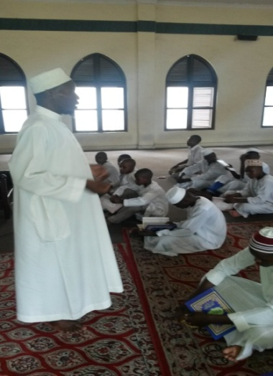

The recitation took place on Thursday 8 jamadiul Akhaar in 1423, which is a sad day for Mashie entire world for the death of a scholar Great as he disappeared on the back of this land with an uphill battle in spreading the wrong message of the Prophet (SAW) and Ahlul his bayt

Late Sayyid Saeed Akhtar Rizvi movement in which he did proclaim the message signature of his grandfather the Prophet (s.a.w.w.) no one who tashaiyah Shia did not pass without effect from Him as to directly or indirectly.

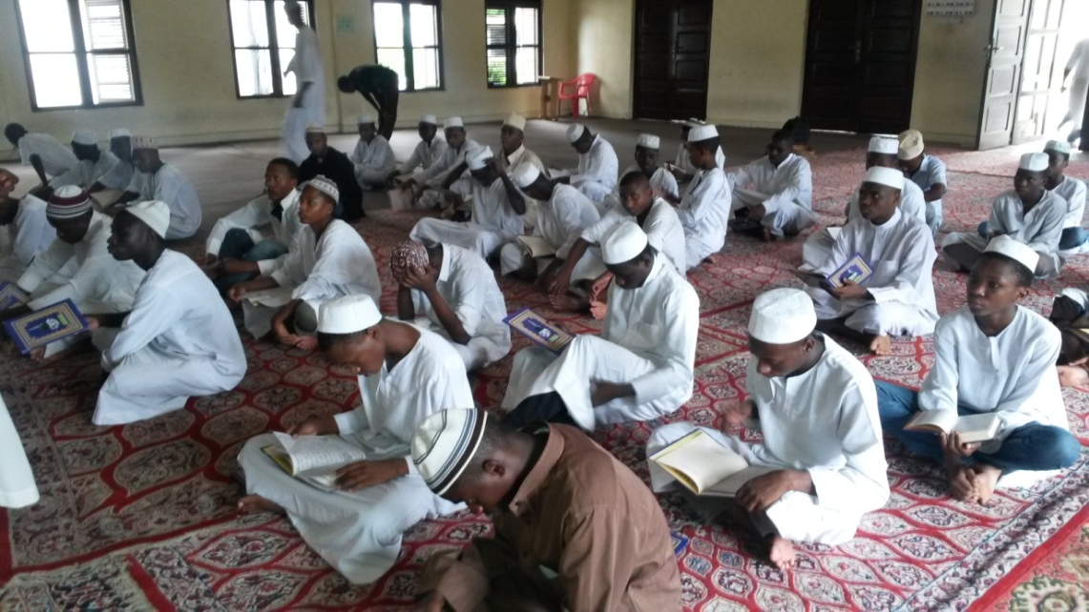

May Allah (s.w.t.) give him all the best, and make us continue to remain under the shadow of our revered scholars.

Sayyid always will abide in our hearts, thoughts and our movements, is a good model for us in East Africa.